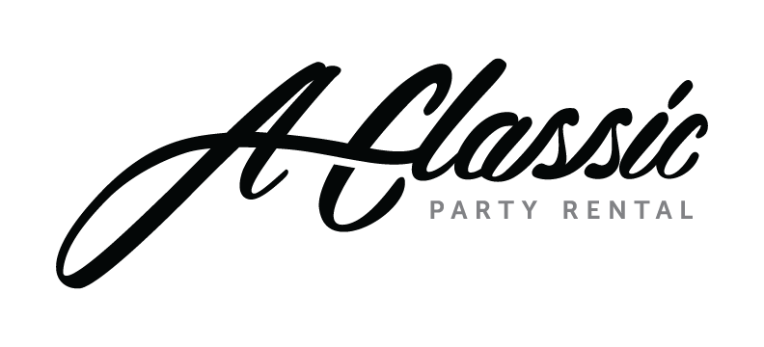
The safety of our employees, customers, partners, and all visitors remains A Classic’s priority. As the coronavirus outbreak continues to evolve, A Classic is monitoring the situation closely and will continue to update and modify our policies and procedures in accordance with all guidance provided by the CDC and WHO.

We kindly ask that you follow these guidelines:
- Upon entering our showroom, please check-in at the front desk and visit one of our hand sanitizing stations.
- Face masks are strongly recommended upon entering our showroom.
- We kindly request that you limit your group to two people. Zoom meetings are available for larger groups.
- Follow the 6’ social distancing guidelines outlined by the CDC.
- Respect all safety measures put in place by A Classic Party Rental.

#AClassicCares #INthistogether
Visitor’s Name: | Mobile Phone:
Visitor’s Company/Organization: | Name of A Classic Host:
SELF-DECLARATION BY VISITOR

1 | Have you experienced any of the following COVID-19 like symptoms in the past 14 days?  - Cough  - Shortness of breath  Or two or more of the following symptoms:  - Fever  - Repeated shaking or chills  - New loss of taste or smell  - Muscle pain  - Sore throat  - Vomiting
2 | Are you willing to wear a mask at A Classic Party Rental to help prevent the spread of COVID-19 to employees and other guests?  Yes / No
3 | Have you had close contact with or cared for someone diagnosed with COVID-19 within the last 14 days?  Yes / No
Have you visited or been in contact with anyone traveling outside of the United States?

Yes / No

If you answered yes to any of these questions above, we can contact you to make alternate arrangements for the requested visit such as rescheduling or connecting with us through FaceTime, Zoom or other digital media options. We look forward to connecting with you soon

Visitor Printed Name: ____________________________________________________________

Visitor Signature: _________________________________ Date: ____________________

