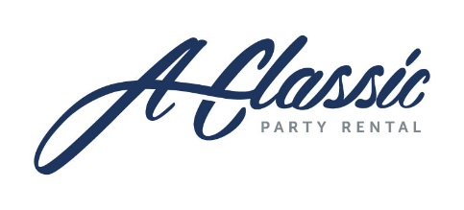
A Classic Party Rental
8020 Zionsville Road
Indianapolis, IN 46268
P: 317-251-7368
www.aclassicpartyrental.com

Application for Donation/Discount

A Classic Party Rental takes great pride in supporting the communities we serve. Please find attached A Classic Party Rental’s donation/discount application. All applications must be submitted a minimum of 90 days prior to your event date to be properly reviewed and appear on our agenda. We understand your commitment and dedication to your organization and in order to give your request the in-depth review that it deserves, we must require this lead-time for adequate study. The Donation Committee will consider your application and you will receive a written decision within 4 weeks of being submitted.
Our Donation/ discount request form is brief and specific; please fill it out completely so that the pertinent information we need is readily available. Please include any literature that you may want us to review and or a brief cover letter highlighting your intentions and or goals.
Please print of type the application and be sure to sign the application at the bottom. Since contributions/ discounts cannot be guaranteed from year to year, organizations must resubmit the application with each new request. Due to the high volume of requests that we receive this procedure is the most expedient way for you to present your request and have it properly reviewed. This program is part of our yearly marketing and advertising budget. As such, we have reasonable expectations that any approved donations will afford us opportunities to develop future business with either attendees or supporters of your event. Any assurances that you can provide this opportunity to us will enhance our consideration of your request.

Please mail your completed application to the address above or email a scanned copy to your account manager. Verbal requests will not be considered.
If you need assistance in completing this form, please call 317-251-7368.

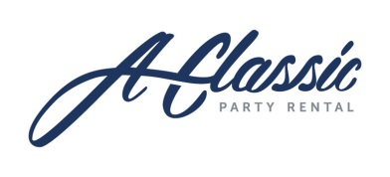
DONATION/SPONSORSHIP REQUEST FORM
Request Form must be received at least 90 days prior to the event for consideration.
BENEFITTING ORGANIZATION:___________________________________________________________
TAX EXEMPTION ID NO. (Please attach a copy of certificate.):__________________________________
MAILING ADDRESS:____________________________________________________________________
MAIN PHONE NUMBER:_________________________________EVENT DATE:____________________
EVENT LOCATION/ADDRESS:____________________________________________________________
CONTACT NAME:______________________________________CELLULAR NUMBER:_______________
EMAIL ADDRESS: ______________________________________________________________________
*PLEASE ATTACH A SUMMARY OF THE EVENT, ALONG WITH A LIST OF REQUESTED RENTAL NEEDS.
Terms and Conditions of Donations/Sponsorships:
A Classic Party Rental has a limited budget for charitable contributions. All organizations requesting a donation or sponsorship must complete a request form. The form will be reviewed by A Classic. The form must be received at least 90 days prior to the event for consideration. If your donation request is approved, you must agree to the following terms and conditions:
*A valid major credit card is required for all orders for security damage purposes.
*A signed A Classic Party Rental Contract with terms and conditions listed will apply to all donated rental equipment and must be received no later than 90 days prior to the event.
*A signed order confirmation sheet must be received 90 days prior to the event.
*A Classic must be mentioned in any and all advertising associated with the event and a proof sent to A Classic for approval.
*If appropriate for the event, an A Classic banner must be displayed throughout the event.
*A Classic does not donate delivery fees, labor charges, or cleaning fees.
*All donations will be reviewed on a case by case basis for approval
I agree to the terms and conditions and wish my donation request to be considered:
_________________________ ___________________________________ ____________________ Print Name Signature Date

